Create a class FRUIT which has data members colour, taste and price. Also create a method display() which will print values of FRUIT object. Create three objects of FRUIT class and call their display() methods.
Question 1:
Week 8

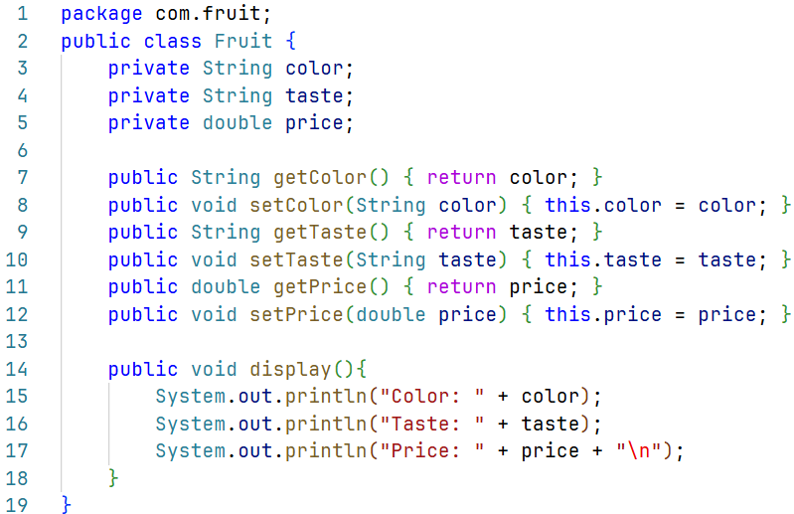
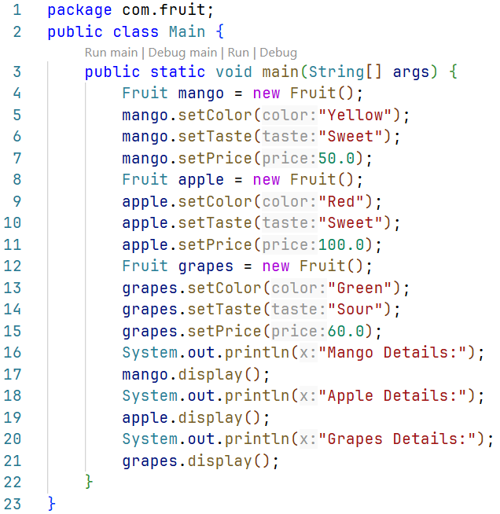
Main.java
Fruit.java
Solution:
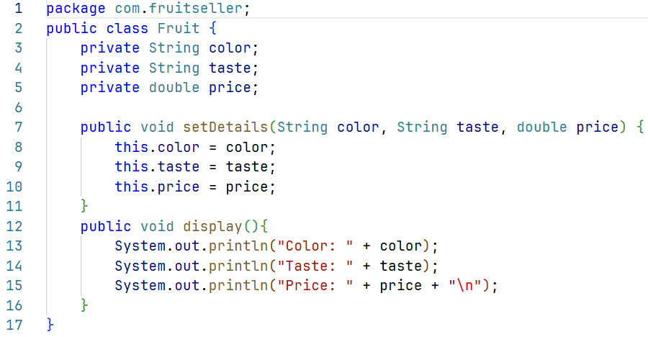
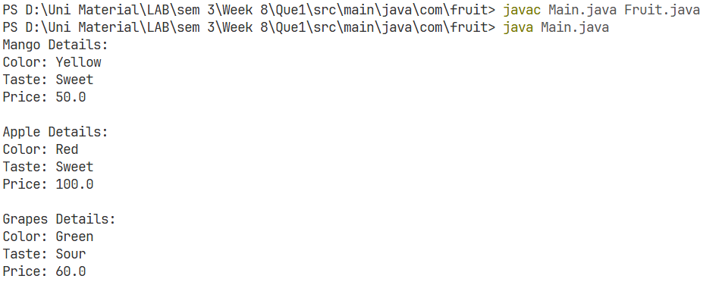
Question 2:
Create a class FRUIT which has data members color, taste and price. It has a method setDetails() which will set the values of color, taste and price. Also create a method display() which will print values of FRUIT object.
Fruit.java
Solution:
Output:
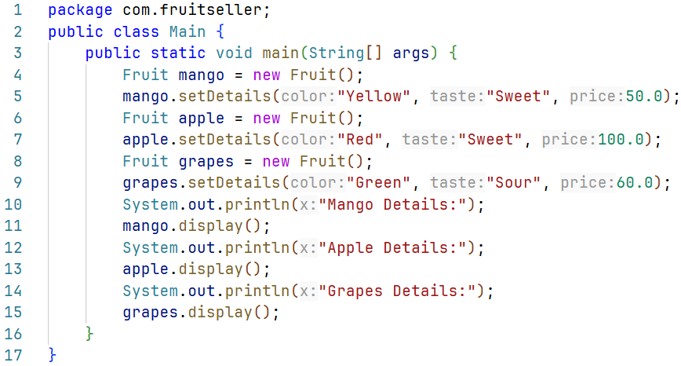
Main.java
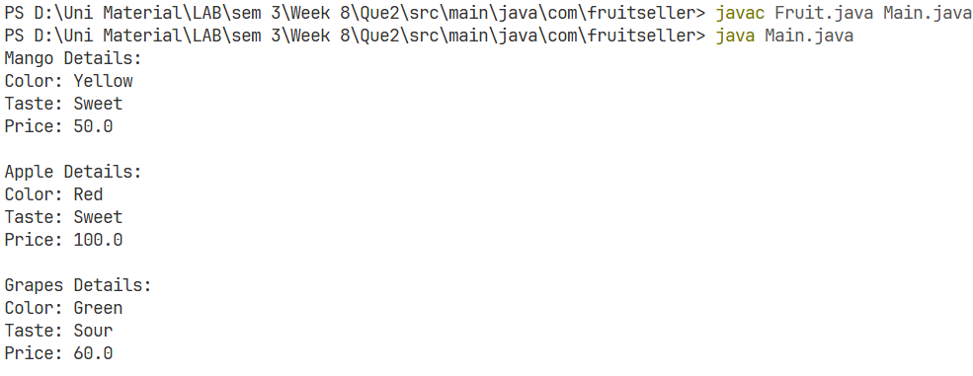
Output:
Fruit.java
Solution:
In previous question, set the values of using color, taste and price using Constructor.
Question 3:
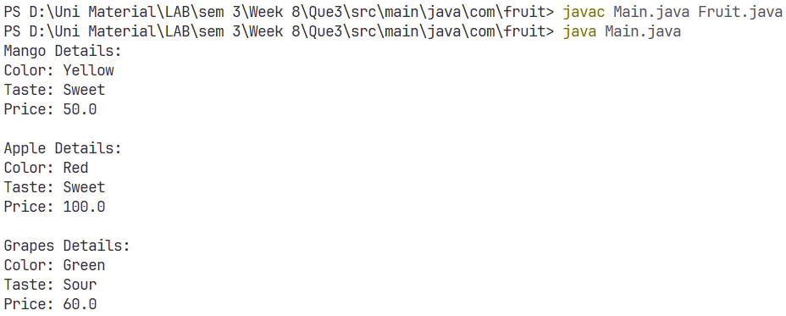
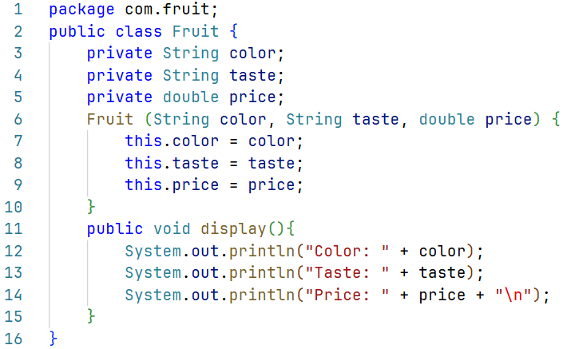
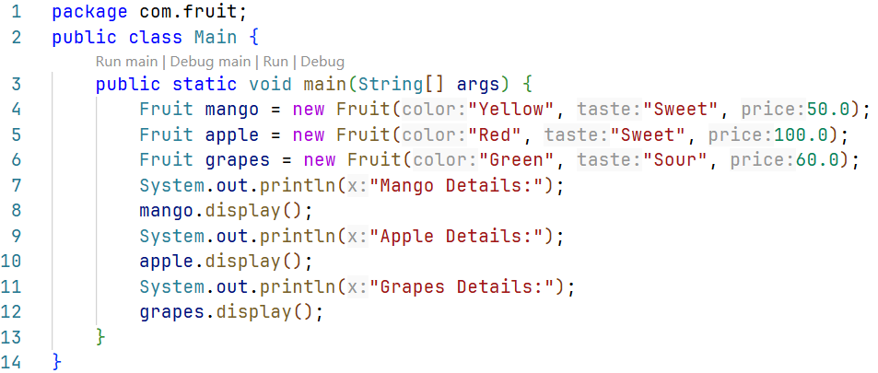
Output:
Main.java
Fruit.java
Solution:
Add one-argument constructor and two-argument constructor in addition to default constructor in FRUIT class.
Question 4:
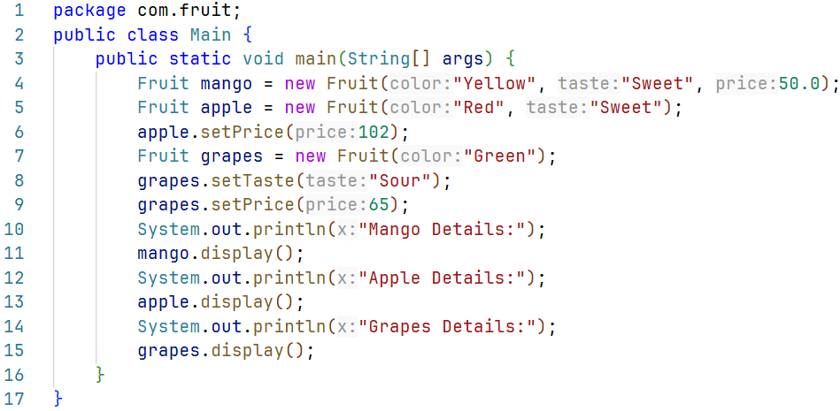
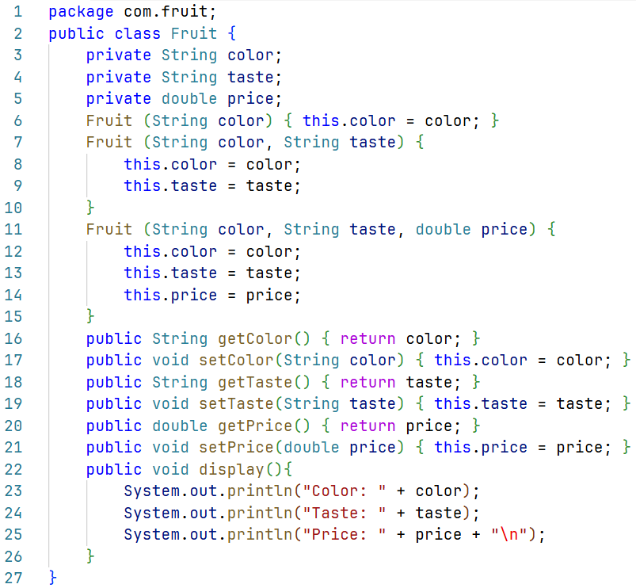
Main.java
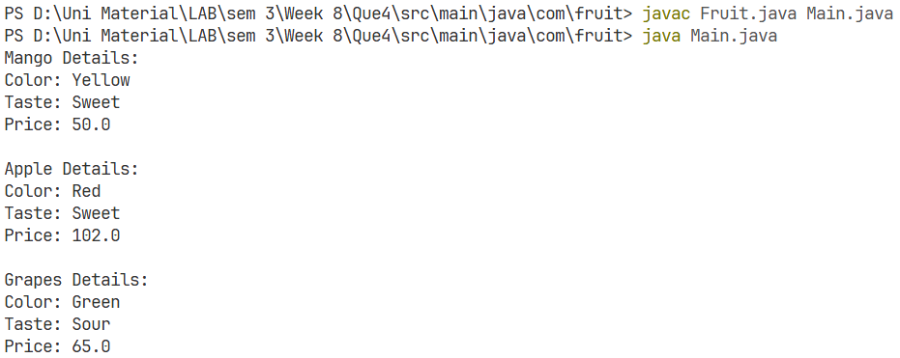
Output:

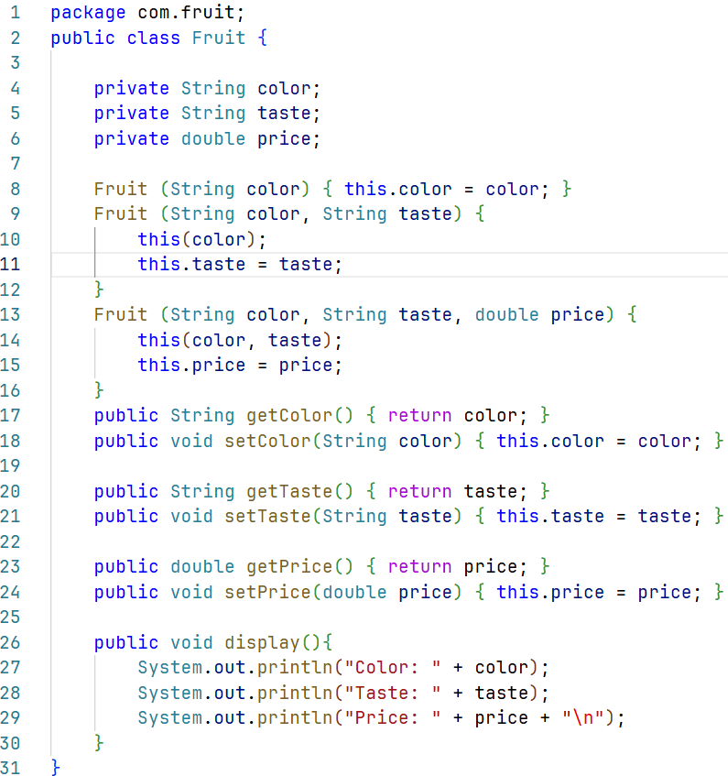
Fruit.java
Solution:
Question 5:
Use the concept of constructor-chaining in the previous question using this().
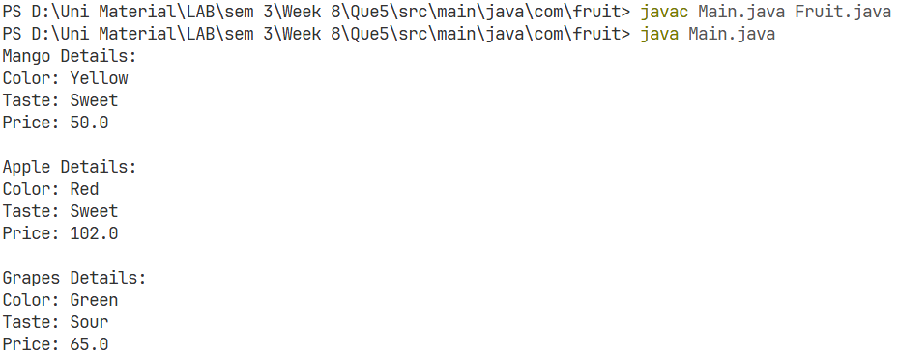
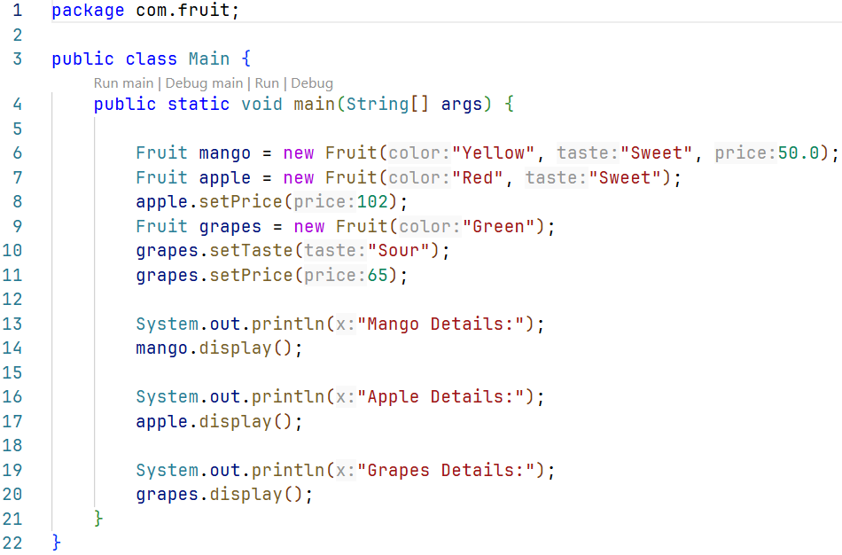
Output:
Main.java
Question 6:
Create a class CAR with the following details:
Data members: model, color, price.
Member methods:
- setDetails() – to set values of all data members using setters.
- getDetails() – to get values of all data members using getters.
- display() – to print all details of the car.
Requirements:
- Implement default constructor to initialize default values.
- Implement a parameterized constructor (with one argument) to
- set only model.
- Implement another parameterized constructor (with two
- arguments) to set model and color.
- Use constructor chaining to reduce code redundancy.
- Create three objects of CAR class using:
- ● Default constructor
- ● One-argument constructor
- ● Two-argument constructor
- Set price for each object using the setDetails() method.
- Call the display() method for each object.
Optional
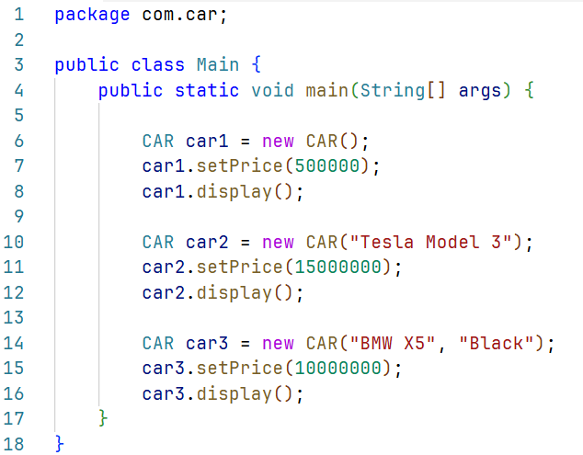
Main.java
Solution:
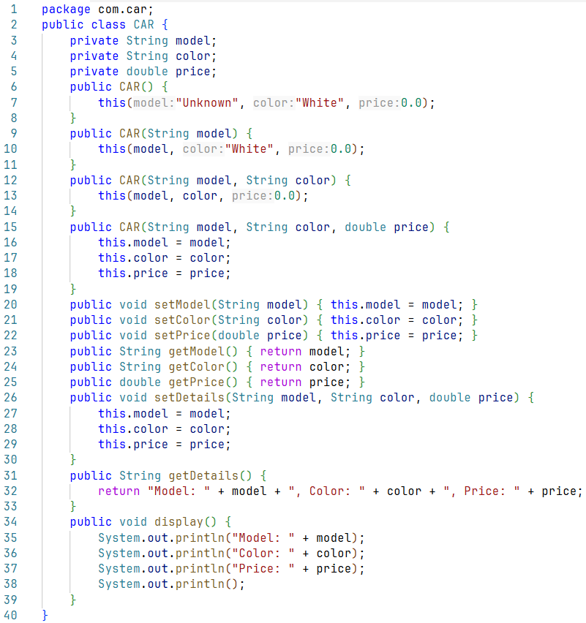
Fruit.java
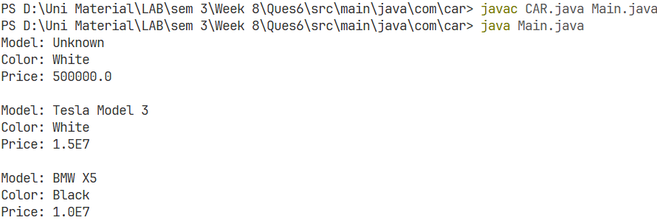
Output:

